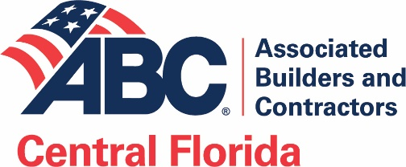

Script for a board member to present membership to a non- member:

This is the profile of a company likely to find benefit in ABC membership:
- Employs at least 20-30 full time employees, has support staff and business development effort
- Over $3M in annual billing and in business for several years
- Works merit shop (but could be a union contractor) (Note: ABC has union contractor members)
- Is located in or works in commercial construction (in Orange, Osceola, Seminole, Lake, Volusia)
- May already work with one or more ABC members
- Takes pride in work (professional web site, brochures, business development effort)
- Joins organizations (like area chamber, EDC, Junior Achievement, ACT, ACE Mentor, etc.)
- Seeks repeat business

You are talking to a subcontractor
Thanks for doing a great job for us. If I haven't told you, I am on the Board of Directors of Associated Builders and Contractors. Are you familiar with ABC? It is a great group of over 400 companies, including several companies you deal with or might want to deal with. ABC is very active on a number of fronts which might benefit you or your staff. I would like to nominate you for membership. Would you like me to have the ABC Membership Director Catherine Wert reach out to you to explain the benefits of membership?

You are a subcontractor talking to a general contractor
We have noticed you take pride in the quality of work you do, and we appreciate your business. If I haven't told you, I on the Board of Directors of Associated Builders and Contractors. Are you familiar with ABC? It is a great group of over 400 companies and offers an opportunity to network with some of the largest and most successful contractors in Central Florida. ABC is very active on a number of fronts which might interest you or your staff. I would like to nominate you for membership. Would you like me to have the ABC Membership Director Catherine Wert reach out to you to explain the benefits of membership?

You are talking to a competitor
I know we compete sometimes on the same projects, but I consider your business a fair and honest competitor, and hope you feel the same about our business. If don’t know if you are aware, but I on the Board of Directors of Associated Builders and Contractors. Are you familiar with ABC? It is a great group of over 400 companies, including several companies you deal with or might want to deal with. ABC is very active on a number of fronts which might benefit you or your staff. I would like to nominate you for membership. Would you like me to have the ABC Membership Director Catherine Wert reach out to you to explain the benefits of membership?
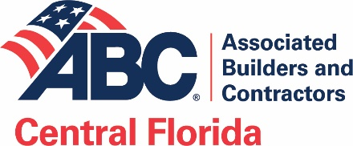
To an unrelated business owner (not a competitor, customer or subcontractor)
I have heard great things about your business and know see you are pretty active in pursuing commercial work in Central Florida. If don’t know, I on the Board of Directors of Associated Builders and Contractors. Are you familiar with ABC? It is a great group of over 400 companies, including several companies you deal with or might want to deal with. ABC is very active on several fronts which might benefit you or your staff. I would like to nominate you for membership. Would you like me to have the ABC Membership Director Catherine Wert reach out to you to explain the benefits of membership?

You are a GC or Sub talking to a professional services firm or materials supplier
You have done a great job for us, and we certainly appreciate your services. I expect you would like to expand your contacts in the Central Florida commercial construction industry. If don’t know, I on the Board of Directors of Associated Builders and Contractors. Are you familiar with ABC? It is a great group of over 400 companies, including several companies you deal with or might want to deal with. Its members read like the “Who’s Who” in the commercial construction community in Central Florida. Membership is not a guarantee of more business, but it certainly positions you with opportunities. I would like to nominate you for membership. Would you like me to have the ABC Membership Director Catherine Wert reach out to you to explain the benefits of membership?

Connect…Educate…Advocate

