Excellence in Construction Awards
2022 Trophy Order Form
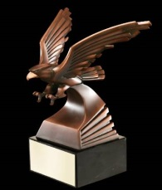  All Eagle Award winning projects will receive (1) complimentary Eagle -  10” Resin Soaring Bronze Eagle  on Rosewood base | 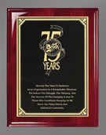  All Award of Merit winning projects will receive (1) complimentary Award of Merit plaque -  7" x 9" Rosewood Piano finish  laser engraved plaque
Ordering Information
If you would like to provide someone on the project team, the owner, architect or engineer with an award trophy or plaque, complete the form below and email to ABC, or click on the link below to order online. Engraving can be custom designed - see samples below. Special wording is available - to order attach a copy of the exact lettering/wording for each award. The number of lines on the soaring eagle and eagle head are limited due to size. There is no deadline to order, will be available for pick up at the ABC office.
Trophy Order Options
 | 10” Resin Soaring Eagle on Rosewood base with engraved plate | 7" x 9" Rosewood Piano Finish laser engraved plaque
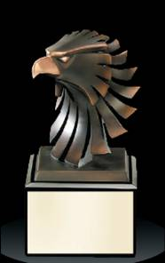 | 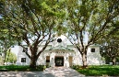  6” high Resin Bronze Eagle Head on base with engraved plate | 10” x 13” Rosewood Piano Finish photo plaque with plate for 5”x7” photo. *Photos: Send one color 5” x 7” (horizontal) photo for each plaque ordered

Date ________________ Order placed by ___________________________________________ Purchase Order # _______________
Company __________________________________________ Phone _______________ Email ________________________________
Project ____________________________________________________________ Category ___________________________________
Award Level __________________________
In ADDITION to what the eagle or award of merit winners receive, I would like to order the following:
Quantity | Format #– see samples on back of form | Item Description | Price Ea. | Total
 |  | 8” Soaring Bronze Eagle on Base (most popular) | $125.00 | $
 |  | 6” Resin Bronze Eagle Head on Base (most popular) | $48.00 | $
 |  | 7’ x 9’ Rosewood Piano Finish Plaque | $38.00 | $
 |  | 10” x 13” Rosewood Piano Finish Photo Plaque-*You supply 5x7 photo | $67.00 | $
 |  | SUBTOTAL |  | $
 |  | Add 6.5% Sales Tax to your order --- |  | $
 |  | TOTAL |  | $

*PHOTOS - Send one color 5" x 7" (horizontal) photograph for each 10” x 13” plaque ordered. Mark your company name and the project name on each picture. Mail photos to ABC, 651 Danville Drive, Suite 200, Orlando, FL 32825-6393.
Please attach special wording or format information for additional trophies ordered.

To order online: https://abccentralflorida.com/product/excellence-in-construction-awards-trophies/

ABC, 651 Danville Drive, Suite 200, Orlando, FL 32825-6393 Phone 407-628-2070 vp@abccentralflorida.org
Sample engraving formats
Format #1 | Format #2 | Format #3
PROJECT NAME  CATEGORY  CONTRACTOR COMPANY NAME | PROJECT NAME  CATEGORY  GC COMPANY NAME  ARCHITECT FIRM NAME  (printed only if requested on form | PROJECT NAME  CATEGORY  SUB COMPANY NAME  GC COMPANY NAME
Format #4 | Format #5 | Format #6
INDIVIDUAL NAME  COMPANY NAME  for exceptional performance on  PROJECT NAME | NAME (individual or company)  for exceptional performance  PROJECT NAME  COMPANY NAME | NAME (individual or company)  in recognition of your support  PROJECT NAME  COMPANY NAME

