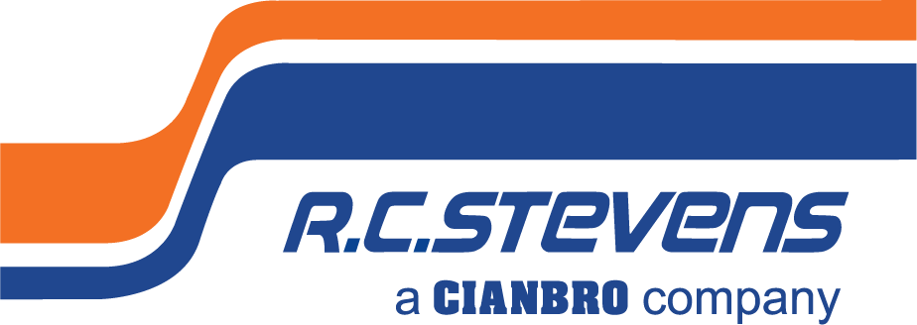
Estimator/Preconstruction

Manager

Full-Time

General Contractor

Commercial Construction

R. C. Stevens Construction Company is the Southeast’s construction industry leader in process industrial
with specialization in food/beverage, manufacturing, and growing healthcare markets including assisted living facilities. Incorporating our core values of quality, innovation, and integrity in all we do, we provide design/build services, general contracting and construction management to our clients and partners. Whether we are expanding manufacturing capability, servicing high profile clients, or building high-tech regional hospitals, we are known for building excellence.

We are seeking a talented, experienced commercial general construction Estimator able to
enthusiastically engage clients, who thrives on attention to detail, accuracy, and responsible for preparing bids, planning, organizing, and scheduling work, and determining cost effectiveness. The ideal candidate will be goal and task oriented, flexible, sociable, team player called upon daily to cultivate existing and new client relationships who flourishes in detailed takeoff work, quickly and accurately. As directed, respond to advertisements for projects to be bid or negotiated based on company marketing objectives. This incumbent will work alongside Project Managers to provide a smooth transition on award projects and subcontract negotiation. The successful candidate will be able to earn the respect of project teams helping them to work cohesively to achieve the high standards R. C. Stevens is known for.

To Be Successful in This Role, You Will Need:
- Bachelor’s degree required in Building Construction, Civil Engineering, Construction Management, other
- construction based educational program for commercial construction projects or relevant discipline preferred.
- Minimum of 5 years prior experience in an Estimating position bidding projects ranging in value between
- $500k up to $10 million with varying complexity within the commercial construction industry, preferably a General Contractor within the state of Florida. Strong knowledge of Divisions 2 through 16, and quantity takeoff experience in Division 2, 3, 4, 6, 8, 9, and 10.
- Conceptual estimating is preferable. Must be able to visualize what will be required to construct a complete project using only schematic or conceptual drawing and relying upon one’s experience to “fill in the gaps”.
- Advanced proficiency using industry specific construction estimating bid takeoff software such as Bluebeam Revu (specifically design, markup, quantity and cost estimate bid takeoff tools). Advanced proficiency (5+ years) using Procore Project Management, Sage 300 CRE, Sage Paperless Construction document storage software, DocuSign, and MS Office 365 (expert level Excel preferred) with efficiency and accuracy expected. Preferably experience using BIM workflows including 2D & 3D proposal presentation as well as 4D animations. Knowledge of Asana project management software is preferred, but not required. Adaptable to new computer software and technology.
- Outgoing personality comfortable talking frequently with diversity of people characteristics and conducting presentation meetings such as with clients and architects, explaining scope and estimates during initial schematic and design development phases of a project.
- High level of judgement, integrity, flexibility, and credibility is critical for this position. DFWP / Background Checks Required.
- A valid state driver license and driving history that meets company standards is required.
- Must be able to travel (may include commercial flights) for training, bid meetings, or visits to construction jobsite to observe work, take measurements, or perform other routine tasks.

Required Position Functions and Duties:
- Aptitude for mathematics to quickly analyze, compare, and interpret information including unspecified
info, then make concise and accurate judgement based on knowledge and experience to establish project timelines and budgets.
- Estimate and lead team of Estimators responsible to prepare competitive bids using familiarity with lump-
sum, time & material, also to solicit subcontractor bids, distribution of plans to qualified bidders, follow up and review of bids. Depending on project level of complexity may work independently or a team environment.
- Track, forecast, analyze blueprints, specifications, proposals, and other documentation to prepare time, costs, and labor estimates for new and renovation of commercial construction projects or construction management services, applying knowledge of specialized methodologies, techniques, principals, or processes.
- Upon completion of quantity surveys, Estimator prepares a total project cost summary including the costs of labor, equipment, materials, subcontractors, taxes, insurance, markup, and any other costs that may affect the project to prepare bid proposals ultimately for client including key stakeholders. Applies and appropriates overhead and profit factors to arrive at total bid price.
- Demonstrate extraordinary client and subcontractor relationship management throughout multiple, simultaneous short- and long-term projects while coordinating with others to execute work procedures.
- Prepares project budgets and assigns cost codes to subcontract and purchase orders.
- Consults and negotiates agreements with subcontractors and suppliers, prepares subcontractor and purchase order commitments.
- Select and maintain heavy contact and involvement with vendors and subcontractors throughout the bidding process, providing answers to scope questions.
- Strong communication and organizational skills to constantly communicate with professionalism in a clear and concise manner, internally and externally, with clients, our departments, as well as outside companies (suppliers, subcontractors, and other business partners) to work together to achieve project objectives from multiple sources.

Why join R. C. STEVENS CONSTRUCTION COMPANY?

Building Your Future is How We Build Ours. We seek out those with the highest potential and provide an empowering environment with tools that allow you to take ownership in your career development.
Stability Means Staying Ahead of the Curve. We're committed to continuous improvement and reinvesting in evolving technologies. To ensure stability, we have a diversified project portfolio in a broad range of niche markets nationwide.
We Are Family. This is why we have an intense commitment to Safety. We want to make sure that every member of our R. C. Stevens family goes home each day to theirs. We foster a culture of teamwork, trust, collaboration, and open communication. Our family-owned company also sponsors wellness and charitable events, casual employee get-togethers, lunch and learns, and other fun social events.
Our Greatest Asset? Our Name. Our 95-year history is grown over time. Our dedication to our people and building trust has enabled us to cultivate long-term relationships with our clients, our partners, and each other. Located in beautiful downtown Winter Garden, Florida, we are a caring corporate citizen employing a strong team of professionals giving back to our community.

We’re Building Something More.

To be considered for this unique opportunity, send you resume and letter of interest with compensation requirements to jobs@rcstevens.com. No phone calls or recruiters please.

ABOUT R. C. STEVENS CONSTRUCTION COMPANY
R. C. Stevens Construction Company is one of the Southeast’s oldest and most experienced construction leaders. Founded in 1926 by builder/architect Raymond C. Stevens, the company has earned wide recognition as a full-service Design/Builder, Construction Manager, General Contractor, and Program Manager specializing in process industrial and manufacturing plants, healthcare, and commercial projects. Please visit our website to learn more at: www.rcstevens.com

ABOUT OUR PARENT COMPANY - CIANBRO
Founded in 1949, Cianbro is one of the highest-ranked contractors in the United States and is one of the largest open-shop, 100% employee-owned construction companies. Prior to acquiring R. C. Stevens, Cianbro successfully integrated Starcon International, a leader in the refinery and petrochemical industry into its team in 2010. In 2019, Cianbro acquired A/Z Corporation, based out of North Stonington, CT. A/Z is an industry leader in design services, life sciences, higher education, defense, healthcare, and mission critical electrical, data and energy systems.
As a 100 percent employee-owned company, team members within The Cianbro Companies participate in the ESOP ownership and share in the successes of the business. As employee-owners, team members have a vested interest to work safe, efficiently, and productively to ensure the successful completion of our projects. The success of The Cianbro Companies is truly a function of its team members – their character, skill, and pride. Please visit Cianbro’s website to learn more at: www.cianbro.com

Cianbro is an employee-owned, tobacco-free, equal opportunity employer, we do not discriminate based on marital status, race, color, creed, gender, sex, religion, national origin, gender identity, age, veteran status, union affiliation, physical or mental disability, citizenship status, sexual orientation, genetic information, or other legally protected status.

