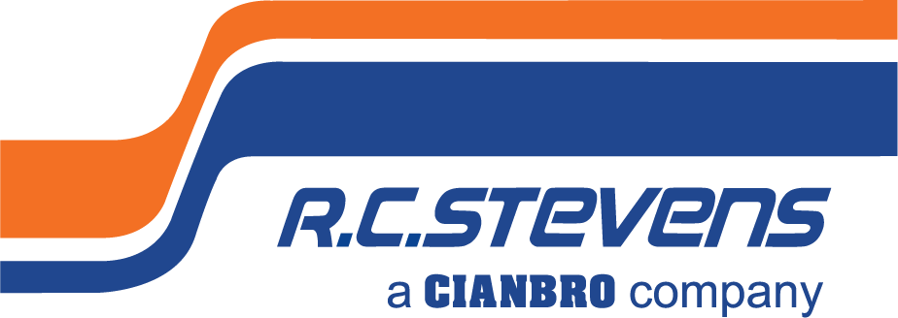
Project Manager – Healthcare

Full-Time

General Contractor

Commercial Construction
R. C. Stevens Construction Company is the Southeast’s construction industry leader in process industrial with specialization in food/beverage, manufacturing, and growing healthcare markets including assisted living facilities. Incorporating our core values of quality, innovation, and integrity in all we do, we provide design/build services, general contracting and construction management to our clients and partners. Whether we are expanding manufacturing capability, servicing high profile clients, or building high-tech regional hospitals, we are known for building excellence.

We are looking for a talented Construction Healthcare Project Manager able to lead our local healthcare division enthusiastically and engage clients, who thrives on attention to detail, accuracy, ability to verify worksite requirements are met, and project specifications are followed to successfully manage project conformance. The ideal candidate will have commercial construction experience adhering to Agency for Health Care Administration (AHCA) regulations or other General Contractor commercial construction industry experience within the state of Florida, be able to demonstrate extraordinary client relationship management, superb project logistic management, the discipline to work independently, as well as work collaboratively to captivate project stakeholders. This incumbent will concentrate efforts in our thriving healthcare division coordinating with others to execute work procedures while demonstrating client relationship management throughout multiple, simultaneous long-term projects. The successful candidate will be able to earn the respect of project teams helping them to work cohesively to achieve the high standards R. C. Stevens is known for. The ideal candidate will be a flexible, detail-orientated team player called upon weekly to service our existing client projects including but not limited to coordinating subcontractor work scopes, scheduling, and logistics to meet objectives throughout projects, as well as expanding our healthcare client base.

To Be Successful in This Role, You Will Need:
- Minimum of 5 years’ experience in commercial construction management, jobsite management and project logistics including management of all construction trades. Recent (past 5 yrs.), relevant commercial healthcare construction experience within the state of Florida.
- Bachelor’s degree required. Higher education in construction management, business management, other construction-based educational program for commercial const. projects or relevant discipline preferred.
- advanced proficiency (5+ yrs.) in Procore Project Management (or similar) software a plus. Proficiency in Sage 300 CRE (f/k/a Timberline Office), Sage Paperless Construction, Textura Payment Management software, DocuSign, and MS Outlook, Word, Excel software with efficiency and accuracy expected. Adaptable to new computer software and technology.
- At least 3 years in a previous position working as Project Manager for a commercial General Contractor. Preferably within the healthcare building construction division responsible for adhering to AHCA (healthcare) regulations or other industrial commercial construction projects.
- Work requires frequent interaction with subcontractors to communicate our standards and assist with project compliance in both an office and field environment.
- At least 5 years in a previous position utilizing superior organization and time management skills; ability to work independently, prioritize workload and meet deadlines consistently. Solid organizational skills.
- Analytical problem-solving skills with excellent attention to detail.
- Strong oral communication skills both internally and externally. Constant communication is required with clients, within our project management department, as well as outside companies (suppliers, subcontractors, and other business partners) to work together to achieve project objectives from multiple sources.
- At least 3 years in a previous position responsible to understand construction industry safety procedures.
- DFWP / Background Checks Required.
- Position requires full-time hours Monday-Friday with additional hours required as needed.
- A valid state driver license and driving history that meets company standards is required.
Required Position Functions and Duties:
- Lead project teams to achieve bottom line results and growth.
- Present and communicate with key stakeholders to cultivate new and existing client relationships.
- Ensure building standards are met particularly with specialized healthcare certifications.
- Prepare competitive bids. Familiarity with lump sum, time & material.
- Serve as a Safety Officer cooperating with our Safety Director to maintain a safe work environment.
- Study specifications to plan procedures for construction on basis of starting and completion times and staffing requirements for each phase of construction.
- Work in a paperless work environment.
- Prepare and communicate field reports on progress, materials used and costs, and adjust work schedules as needed after evaluation of project reports.
- Resolve complaints and grievances which may arise with professionalism in a clear and concise manner.
Why join R. C. STEVENS CONSTRUCTION COMPANY?

Building Your Future is How We Build Ours. We seek out those with the highest potential and provide an empowering environment with tools that allow you to take ownership in your career development.
Stability Means Staying Ahead of the Curve. We're committed to continuous improvement and reinvesting in evolving technologies. To ensure stability, we have a diversified project portfolio in a broad range of niche markets nationwide.
We Are Family. This is why we have an intense commitment to Safety. We want to make sure that every member of our R. C. Stevens family goes home each day to theirs. We foster a culture of teamwork, trust, collaboration, and open communication. Our family-owned company also sponsors wellness and charitable events, casual employee get-togethers, lunch and learns, and other fun social events.
Our Greatest Asset? Our Name. Our 95-year history is grown over time. Our dedication to our people and building trust has enabled us to cultivate long-term relationships with our clients, our partners, and each other. Located in beautiful downtown Winter Garden, Florida, we are a caring corporate citizen employing a strong team of professionals giving back to our community.

We’re Building Something More.

To be considered for this unique opportunity, send you resume and letter of interest with compensation requirements to jobs@rcstevens.com. No phone calls or recruiters please.

ABOUT R. C. STEVENS CONSTRUCTION COMPANY
R. C. Stevens Construction Company is one of the Southeast’s oldest and most experienced construction leaders. Founded in 1926 by builder/architect Raymond C. Stevens, the company has earned wide recognition as a full-service Design/Builder, Construction Manager, General Contractor, and Program Manager specializing in process industrial and manufacturing plants, healthcare, and commercial projects. Please visit our website to learn more at: www.rcstevens.com.

ABOUT OUR PARENT COMPANY - CIANBRO
Founded in 1949, Cianbro is one of the highest-ranked contractors in the United States and is one of the largest open-shop, 100% employee-owned construction companies. Prior to acquiring R. C. Stevens, Cianbro successfully integrated Starcon International, a leader in the refinery and petrochemical industry into its team in 2010. In 2019, Cianbro acquired A/Z Corporation, based out of North Stonington, CT. A/Z is an industry leader in design services, life sciences, higher education, defense, healthcare, and mission critical electrical, data and energy systems.
As a 100 percent employee-owned company, team members within The Cianbro Companies participate in the ESOP ownership and share in the successes of the business. As employee-owners, team members have a vested interest to work safe, efficiently, and productively to ensure the successful completion of our projects. The success of The Cianbro Companies is truly a function of its team members – their character, skill, and pride. Please visit Cianbro’s website to learn more at: www.cianbro.com

Cianbro is an employee-owned, tobacco-free, equal opportunity employer, we do not discriminate based on marital status, race, color, creed, gender, sex, religion, national origin, gender identity, age, veteran status, union affiliation, physical or mental disability, citizenship status, sexual orientation, genetic information, or other legally protected status.

