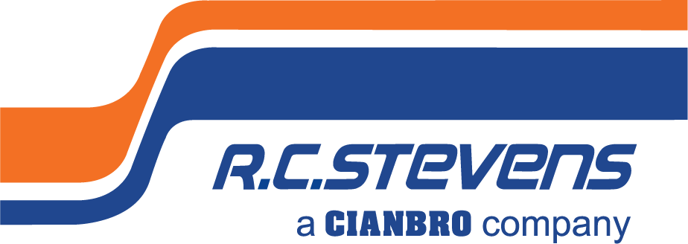
Superintendent – Healthcare

Full-Time

General Contractor

commercial construction
R. C. Stevens Construction Company is the Southeast’s construction industry leader in process industrial with specialization in food/beverage, manufacturing, and growing healthcare markets including assisted living facilities. Incorporating our core values of quality, innovation, and integrity in all we do, we provide design/build services, general contracting and construction management to our clients and partners. Whether we are expanding manufacturing capability, servicing high profile clients, or building high-tech regional hospitals, we are known for building excellence.
We are looking for a Construction Healthcare Superintendent able to perform a variety of construction tasks with stringent adherence to healthcare building standards, work intricately with our Project Managers, who thrives on attention to detail, accuracy, ability to verify worksite requirements are met, and project specifications are followed to successfully direct activities of fellow employees and subcontractors to achieve project conformance. The ideal candidate will have commercial construction experience adhering to Agency for Health Care Administration (AHCA) regulations. The ideal candidate will be a flexible, detail-orientated team player called upon weekly to service our existing client projects including but not limited to coordinating subcontractor work scopes, scheduling, and logistics to meet objectives throughout projects, as well as knowledgeable in reading blueprints and following project specifications. The successful candidate will be able to earn the respect of project teams helping them to work cohesively to achieve the high standards R. C. Stevens is known for.

To Be Successful in This Role, You Will Need:
- Minimum of 5 years’ experience in commercial construction, jobsite management and project logistics including management of all construction trades. Preferably within the healthcare building construction division responsible for adhering to AHCA (healthcare) regulations.
- At least 2 years in a previous position working within an occupied healthcare facility utilizing Infection Control Risk Assessment (ICRA) guidelines.
- High school diploma or equivalent required. Higher education in construction management, business management, other construction-based educational program for commercial const. projects or relevant discipline preferred.
- Advanced (5+ yrs.) using industry specific construction software for project mgmt., scheduling, as well as paperless document storage software. Preferably experience using Procore Project Management, MS Project, Sage 300 CRE (f/k/a Timberline Office), Sage Paperless Construction, Textura Payment Management, DocuSign, and MS Office.
- Demonstrate technical skills and literacy in construction documents and drawings (such as shop, architectural, and structural).
- Work requires frequent interaction with subcontractors to communicate our standards and assist with project compliance in both an office and field environment.
- Experience directing project scheduling, utilizing superior organization and time management skills; ability to work independently, prioritize workload and meet deadlines consistently.
- Analytical problem-solving skills with excellent attention to detail.
- Strong oral communication skills both internally and externally. Constant communication is required with outside companies (suppliers, subcontractors, and other business partners), clients, as well as within our project management department to work together to achieve project objectives from multiple sources.
- At least 3 years in a previous position responsible to understand construction industry safety procedures.
- DFWP / Background Checks Required.
- Position requires full-time hours Monday-Friday with additional hours required as needed. Ability to work overtime. May periodically require long hours and weekend work.
- A valid state drivers’ license and driving history that meets company standards is required. Must be willing to travel.

Required Position Functions and Duties:
- Ability to travel to various jobsites using personal transportation to report timely is expected. Some out-of-area and overnight travel is possible to periodically support other jobsites.
- Conduct all business in a professional and ethical manner to serve customers and increase the goodwill and profit of the company.
- Review project cost projections with Project Manager and make recommendations for cost reductions, scheduling, and projections. Prepare look ahead schedules and overall long-term schedule.
- Assist the Project Manager with pricing efforts, developing scopes of work, locating and evaluating potential subcontractors and suppliers for review and approval by Project Managers.
- Coordinate the interpretation of the specifications, resolving problems, and coordinate phases of construction to prevent delays.
- Log daily progress and photo documentation timely into project specific database.
- Work in a paperless work environment.
- Direct subcontractors and provide leadership in the day-to-day planning and executing of quality work. Plan sequence of activities and durations per proposed schedule and manpower requirements for each phase of construction based on building method, knowledge of available tools and equipment, and personnel resources.
- Mentor subordinates in their career development and progress.
- Call for intermediate and final building inspections and coordinates the building inspections of specialty trades.
- Lead and present at contractor meetings with key stakeholders to communicate project scheduling, coordination, and safety. Participate in or lead Owner/Architect meetings.
- Confer with supervisory personnel and labor representatives, engineering personnel, inspectors, to resolve complaints and grievances and/or construction problems which may arise with professionalism in a clear and concise manner.
- Notify subcontractors and suppliers of nonconformance work within 48 hours and follows through with the notifications. Maintains and completes the deficient work list.
- Ensure building standards are met particularly with specialized healthcare certifications and that construction schedules are met. Responsible to study contract documents to become very familiar with the requirements outlined, able to plan and anticipate potential problems before they arise.
- Maintain a clean jobsite; pick up all tools and equipment and secure jobsite each day to eliminate potential hazards.
- Act as primary field safety representative cooperating with our Safety Director to maintain a safe work environment. Complete all work in compliance with the company’s operating safety policies and procedures. Maintain a safe work environment and ensure proper safety and incident reporting procedures are followed. Bring near miss or problems to the attention of the safety director, project manager, or HR.

Why join R. C. STEVENS CONSTRUCTION COMPANY?

Building Your Future is How We Build Ours. We seek out those with the highest potential and provide an empowering environment with tools that allow you to take ownership in your career development.
Stability Means Staying Ahead of the Curve. We're committed to continuous improvement and reinvesting in evolving technologies. To ensure stability, we have a diversified project portfolio in a broad range of niche markets nationwide.
We Are Family. This is why we have an intense commitment to Safety. We want to make sure that every member of our R. C. Stevens family goes home each day to theirs. We foster a culture of teamwork, trust, collaboration, and open communication. Our family-owned company also sponsors wellness and charitable events, casual employee get-togethers, lunch and learns, and other fun social events.
Our Greatest Asset? Our Name. Our 95+ year history has grown over time. Our dedication to our people and building trust has enabled us to cultivate long-term relationships with our clients, our partners, and each other. Located in beautiful downtown Winter Garden, Florida, we are a caring corporate citizen employing a strong team of professionals giving back to our community.

We’re Building Something More.

To be considered for this unique opportunity, send you resume and letter of interest with compensation requirements to jobs@rcstevens.com. No phone calls or recruiters please.

ABOUT R. C. STEVENS CONSTRUCTION COMPANY
R. C. Stevens Construction Company is one of the Southeast’s oldest and most experienced construction leaders. Founded in 1926 by builder/architect Raymond C. Stevens, the company has earned wide recognition as a full-service Design/Builder, Construction Manager, General Contractor, and Program Manager specializing in process industrial and manufacturing plants, healthcare, and commercial projects. Please visit our website to learn more at: www.rcstevens.com.

ABOUT OUR PARENT COMPANY - CIANBRO
Founded in 1949, Cianbro is one of the highest-ranked contractors in the United States and is one of the largest open-shop, 100% employee-owned construction companies. Prior to acquiring R. C. Stevens, Cianbro successfully integrated Starcon International, a leader in the refinery and petrochemical industry into its team in 2010. In 2019, Cianbro acquired A/Z Corporation, based out of North Stonington, CT. A/Z is an industry leader in design services, life sciences, higher education, defense, healthcare, and mission critical electrical, data and energy systems.
As a 100 percent employee-owned company, team members within The Cianbro Companies participate in the ESOP ownership and share in the successes of the business. As employee-owners, team members have a vested interest to work safe, efficiently, and productively to ensure the successful completion of our projects. The success of The Cianbro Companies is truly a function of its team members – their character, skill, and pride. Please visit Cianbro’s website to learn more at: www.cianbro.com

Cianbro is an employee-owned, tobacco-free, equal opportunity employer, we do not discriminate based on marital status, race, color, creed, gender, sex, religion, national origin, gender identity, age, veteran status, union affiliation, physical or mental disability, citizenship status, sexual orientation, genetic information, or other legally protected status.

