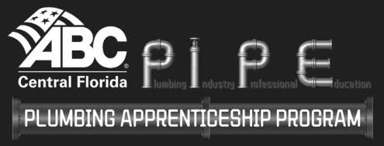

Apprentice Release Form
The ABC Central Florida PIPE Plumbing Apprenticeship Program’s Policies and Procedures state that apprentices are not allowed to switch companies without first consulting with and getting permission from the Apprenticeship Committee. Apprentices are expected to commit to their sponsoring company and not change employers during their time in the program unless released by their employer.
This form is to notify ABC Central Florida’s PIPE Plumbing Apprenticeship Program that an apprentice is no longer employed with our company.
Today’s Date: ____________
Company Name: _______________________________________________________
Apprentice Name: ______________________________________________________
Last Day of Employment: _________________________________________________
Apprentice: Terminated: _______ Laid Off: _______ Quit: _______
Apprentice Eligible for Rehire: _____________________________________________
Reason: ______________________________________________________________________________________
_____________________________________________________________________________________________
_____________________________________________________________________________________________
_____________________________________ _____________________________________
Employer Signature Apprenticeship Coordinator Signature
__________________ _________________
Date Date

